

**Disclaimer: The content is curated from online/offline resources and used for educational purpose only**



**LAB MANUAL**

**Unit I – Foundation of Green Skilling, Sustainability and AI Contributions**

**Unit I – Foundation of Green Skilling, Sustainability and AI Contributions**

**Lab - 1**

**Case Study: Skill Council for Green Jobs (SCGJ)**



[**Source Link**](https://www.google.com/imgres?q=Skill%20Council%20for%20Green%20Jobs%20(SCGJ)&imgurl=x-raw-image%3A%2F%2F%2Fdec34c1901a1cc6a78c62489c9d543ad63f1ddd8ff0998afb4555f60fb6ba3a3&imgrefurl=https%3A%2F%2Fsscgj.in%2Fwp-content%2Fuploads%2F2016%2F10%2FBooklet_Qualification-Pack-SCGJ.pdf&docid=YAsNLekMiAgNIM&tbnid=asyhARlMw94QXM&vet=12ahUKEwiXq56PxOCIAxXQR2wGHRfKIVEQM3oECGUQAA..i&w=707&h=229&hcb=2&ved=2ahUKEwiXq56PxOCIAxXQR2wGHRfKIVEQM3oECGUQAA)

**Introduction**

Skill Council for Green Jobs is another one of the most newly launched initiatives of the Government of India in pursuance of the National Skill Development Mission. The MNRE and Confederation of Indian Industry promote it. The SCGJ was sanctioned for establishment in the 10th meeting of National Skill Qualifications Committee held on 28th September 2015. The SCGJ was established as a not-for-profit, independent, industry-driven society with incorporation under the Societies Registration Act XXI, 1860 on 1st October, 2015.



[Source Link](https://sscgj.in/)

**Mission:**

To identify the need for skilling service users as well as manufacturers/ service providers, in the Green Businesses sector, and to implement country-wide, industry led, collaborative skills development and entrepreneur development initiatives that will empower the meeting of India's potential for "Green Businesses".

**Objectives:**

For example, the SCGJ increases green skills development to complement rising demands for a sustainable workforce. It also promotes industrial cooperation to determine and develop national standards and qualifications on green jobs. SCGJ seeks to expand employment opportunities by training attached to market demands. The council, besides all this, helps in realization towards Sustainable Development Goals while making people understand sustainability. Generally, SCGJ intends to empower communities through the availability of accessible training and resources on the issues of environmental conservation.

**SCGJ aims to:**

1. Workforce: Train and develop a skilled workforce to do work in the green sector, including renewable energy and waste management with sustainable practices.
2. Industry-Gap Bridge : Enhance bridging of industry requirements with skill development programs.
3. Promote Green Skills and Sustainable Practices: Promote green skills and sustainable practices in all sectors.

**Key Initiatives:**

1. [**Training Programs:** SCGJ offers a range of training programs, including the “Hands-on Masterclass: Rooftop Solar,” which provides practical skills and comprehensive knowledge in the rooftop solar industry](https://sscgj.in/). ([Link](https://www.qrencia.com/courses/vocational/renewable-energy/24c3c202_QCR-10000261))
2. [**Certification:** SCGJ is recognized as the awarding body for green business and environment sectors by the National Council for Vocational Education and Training (NCVET)](https://sscgj.in/).
3. [**Industry Collaboration:** SCGJ collaborates with various industry partners to ensure that the training programs are aligned with industry needs and standards](https://sscgj.in/).

The Skill Council for Green Jobs (SCGJ) focuses on several key sectors that are vital for promoting sustainability and creating green jobs. Below are the primary sectors covered under SCGJ:

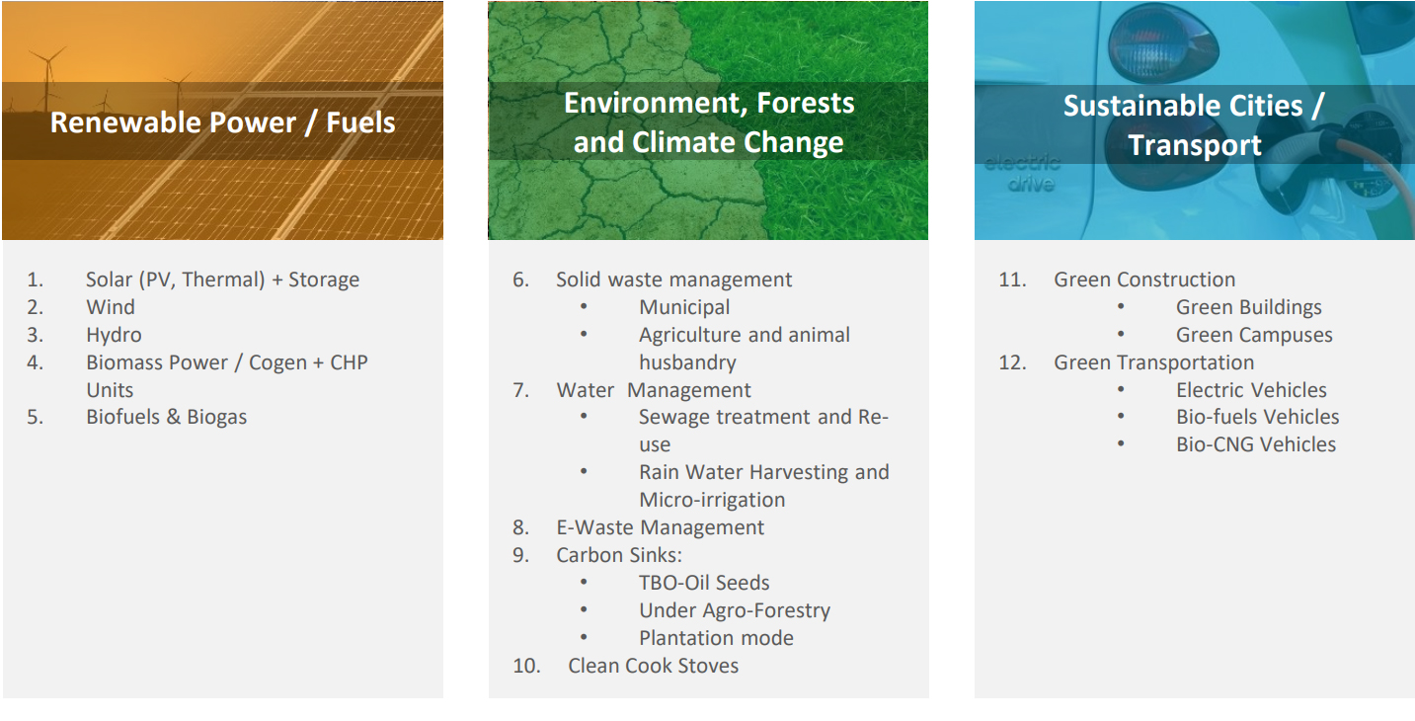

[Source Link](https://www.google.com/url?sa=i&url=https%3A%2F%2Fsscgj.in%2Fabout-us%2F&psig=AOvVaw0QuWBZX9owP09R-W-2V1Mn&ust=1727438111447000&source=images&cd=vfe&opi=89978449&ved=0CBQQjRxqFwoTCNisy9LG4IgDFQAAAAAdAAAAABAE)

**Renewable Power/Fuels**

* **Overview:** Production, installation, and maintenance skills on renewable energy systems including solar, wind, bioenergy, and hydroelectric systems.
* **Skills Development:** Education on energy efficiency, on-grid management, and productive clean fuel feedstock.

**Environment**

* **Summary:** Competencies related to environmental protection, natural resource conservation, and efficient sustainability best practices in various industries.
* Skills Development Training on environmental management, waste management, control of pollution, and resource utilization with sustainability.

**Forests and Climate Change**

* Summary Skills for managing forests, conservation practices, and strategies to mitigate impacts of climate change through sustainable forestry management.
* Skills Development Training on biodiversity conservation, afforestation techniques, and climate-resilient agricultural practices.

**Sustainable Cities/Transport**

* Overview: Focus areas encompass skills in the development of sustainable urban environments and efficient transport systems, which reduce carbon footprints.
* Skills Development: Education / Training in Urban Planning, sustainable transport solution, public transit, and cycling as well as smart city technologies.

**Ongoing Projects Under the Skill Council for Green Jobs (SCGJ)**

|  |  |  |  |  |  |
| --- | --- | --- | --- | --- | --- |
| Sector | Project Name | Aim | Objective | Start Date | End Date |
| Renewable Power/Fuels | **Solar Power for All (SPFA)** | Provide solar energy training to rural communities | Enable participants to install and maintain solar panels, promoting renewable energy use. | January 2022 | Ongoing |
| Renewable Power/Fuels | **Wind Energy Training Program (WETP)** | Train individuals in wind turbine installation and maintenance | Equip local technicians with the skills to work in the growing wind energy sector. | March 2021 | Ongoing |
| Environment | **Waste to Wealth Project** | Train communities in waste management techniques | Promote sustainable practices through recycling and composting, reducing landfill waste. | April 2020 | Ongoing |
| Environment | **Environmental Awareness Campaigns** | Raise awareness about pollution control | Educate urban citizens on reducing their environmental footprint through workshops and events. | June 2021 | Ongoing |
| Forests and Climate Change | **Afforestation Projects** | Engage communities in reforestation efforts | Train local communities in tree planting and sustainable forest management practices. | February 2021 | Ongoing |
| Forests and Climate Change | **Biodiversity Conservation Initiatives** | Monitor forests and engage communities in conservation | Provide training on biodiversity importance and involve communities in conservation efforts. | August 2020 | Ongoing |
| Sustainable Cities/Transport | **Smart Cities Mission (India)** | Create sustainable urban environments | Train city officials and urban planners in sustainable practices for urban development. | January 2020 | Ongoing |
| Sustainable Cities/Transport | **Electric Vehicle (EV) Promotion Programs** | Train technicians in electric vehicle maintenance | Support the transition to electric vehicles by equipping mechanics with necessary skills. | November 2021 | Ongoing |

These key sectors under SCGJ reveal its commitment to developing skills and competencies in support of creating green jobs and to promoting sustainability in the industries. In working towards these areas, SCGJ is building a manpower for effective contributions in conservation efforts and sustainable development..

**Impact**

1. **Employment Opportunities:** SCGJ has played a major role in jobs creation in the green sector. For instance, the collaboration between J.P. Morgan and Sattva Consulting mapped out the green jobscapes in India, speaking of vibrant sectors and opportunities.
2. **Upskilling Workers:** SCGJ focuses on upgrading the skills of workers in MSMEs at the grass root levels, who engage in activities related to waste management and renewable energy2. Such an initiative helps in identification of green skills learned through Non-Formal Learning, which gets upgraded.

1. **Sustainable Development:** SCGJ aligns with Indian sustainable development goals (SDGs) and helps promote the National Solar Mission through green skills and best practices.

**Challenges**

1. **Awareness and Adoption:** One of the primary challenges is raising awareness about the importance of green skills and encouraging adoption among industries and workers.
2. **Funding and Resources:** Ensuring adequate funding and resources for training programs and initiatives is crucial for the sustained impact of SCGJ’s efforts.

**Conclusion**

One of the leading organizations in Indian green skills and sustainable practices is the Skill Council for Green Jobs (SCGJ). SCGJ does not merely help in the increased generation of employment opportunities, but it also endorses the country's sustainable development goals through all of its diverse initiatives. The follow-through support, alliance with industry partners, and all the other requirements will be pivotal to SCGJ's further deepening of their influence and achieving much more objectives.